AI Based FAQ Chatbot with Voice Assistance

In this project we are developing Voice based Chatbot which will utilize AI power to match and predict best answer for user given question. This project consist of following modules

1. Admin: admin can login to system using username and password as ‘admin’ and then can add FAQ new questions and answers and once new question added then AI model automatically get trained to accommodate new question data. Admin can view all registered users
2. User: user can sign up and login to system and then can start Voice based Chatbot and then record and send his question and then AI will analyse question to predict best answer and reply to user with recommended questions.
3. Extension Concept: in this project as extension we are making Chatbot to save all recorded voices which user can play and download and this feature is not exists in any existing voice based Chatbot.

To run project copy content from DB.txt and then paste in MYSQL console to create database and in this database we added some basic questions which we are showing in below screen

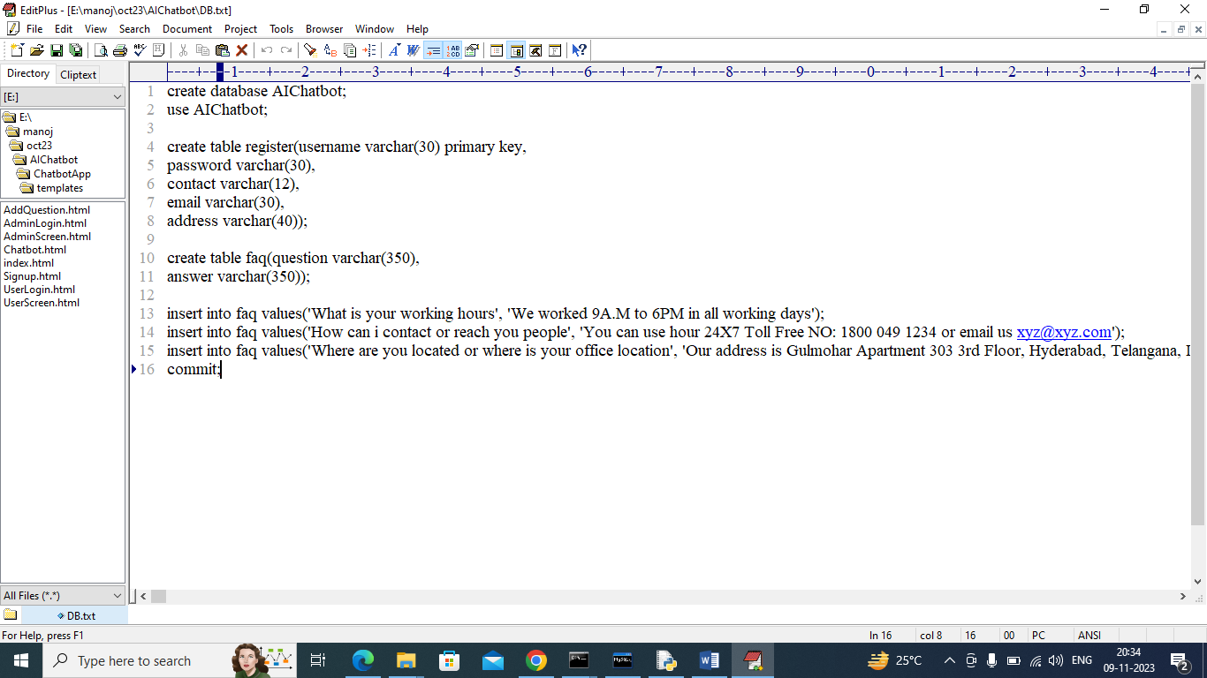

In above database queries in last lines we added some default FAQ questions and you can add new questions by using admin module

SCREEN SHOTS

To run project double click on ‘run.bat’ file to start python server and get below page

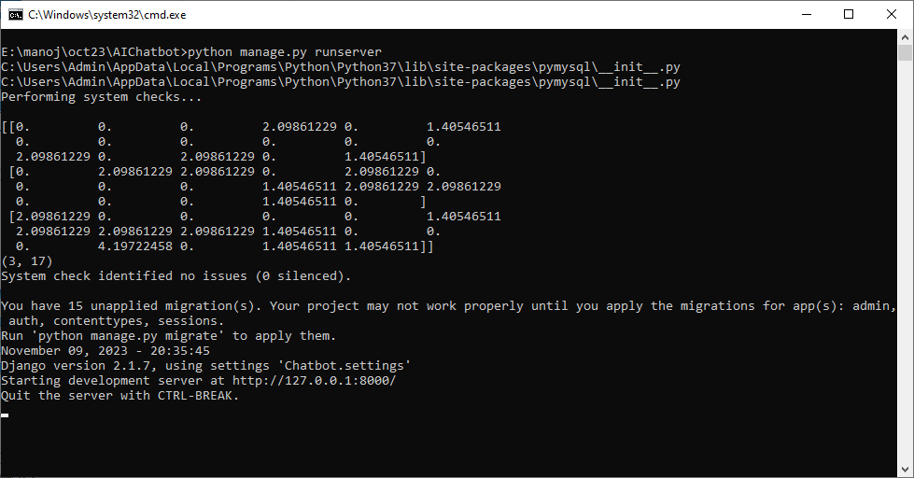

In above screen python web server started and now open browser and enter URL as <http://127.0.0.1:8000/index.html> and press enter key to get below page

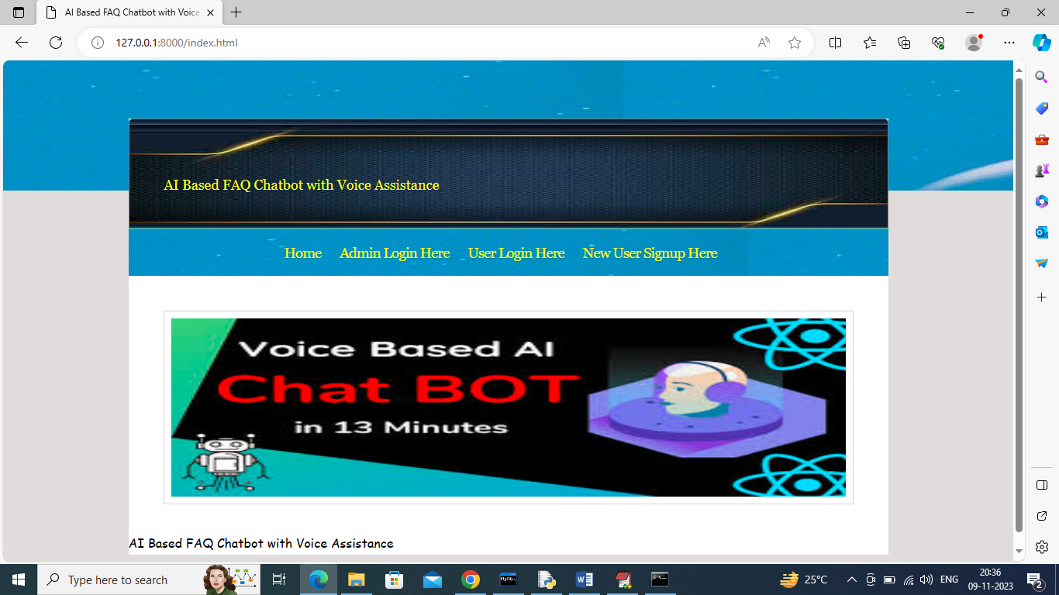

In above screen click on ‘Admin Login Here’ link to get below admin login page

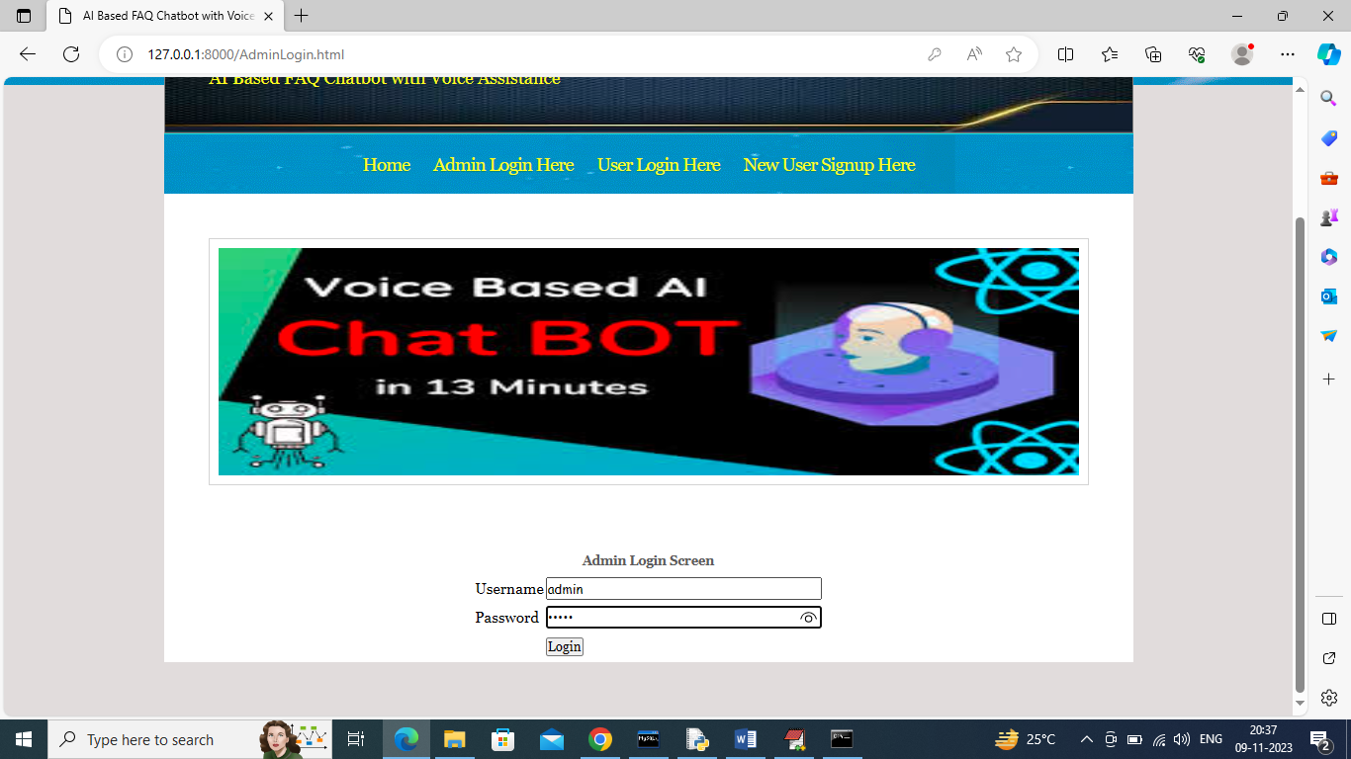

In above screen admin is login and after login will get below page

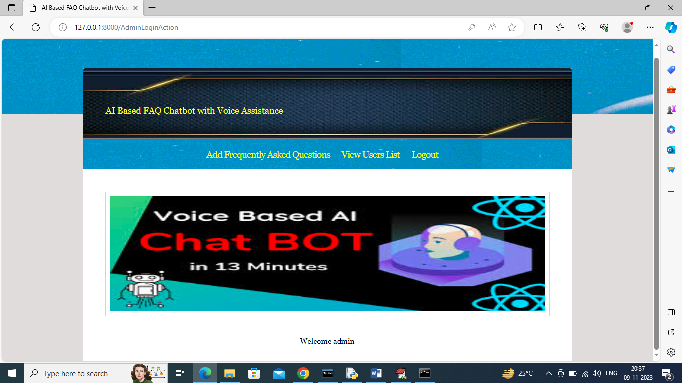

In above screen admin can click on ‘Add Frequently Asked Questions’ link to get below page

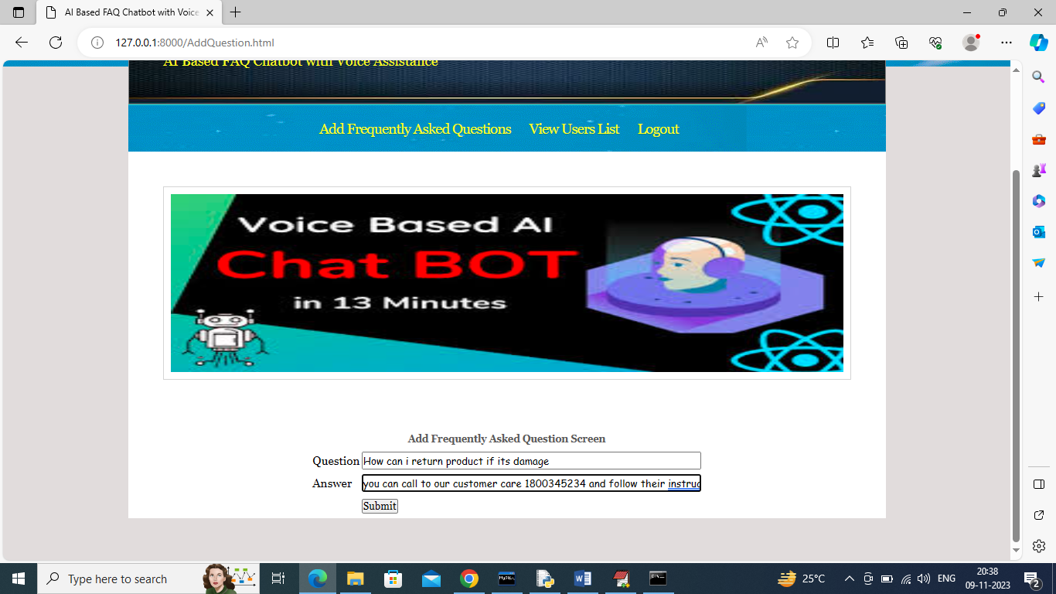

In above screen admin is adding new questions and then click button to save FAQ in database and get below output

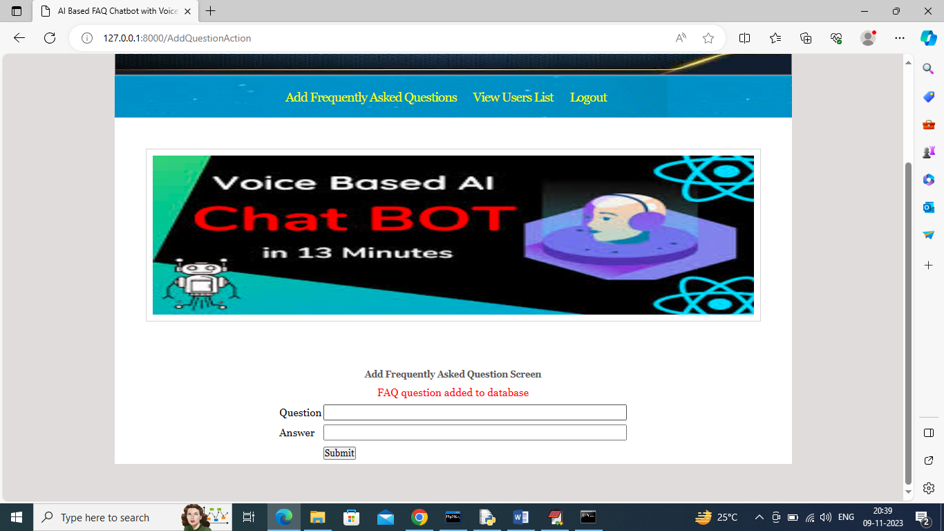

In above screen FAQ is added in database and now click on ‘View Users’ link to get below page

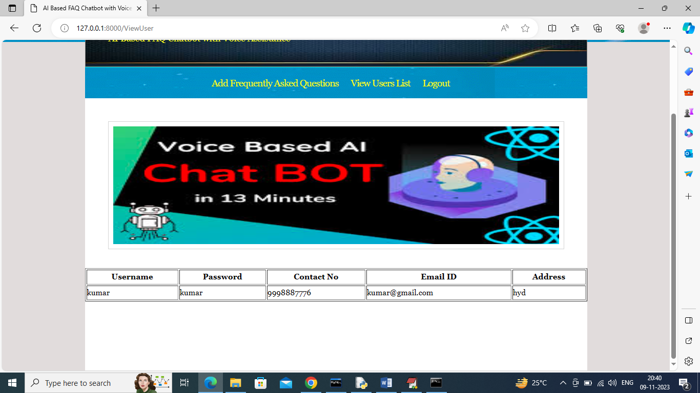

In above screen admin can view list of registered users and now logout and sign up new user

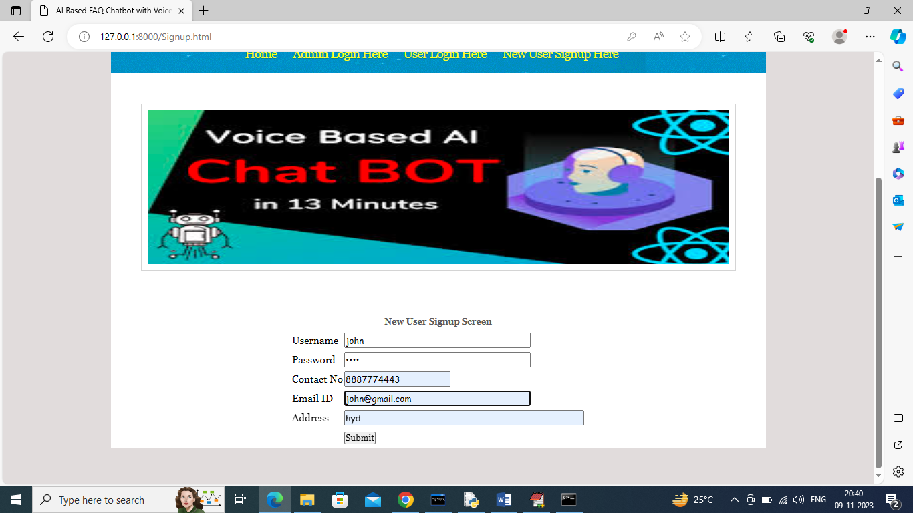

In above screen signing up new user and then click button to get below page

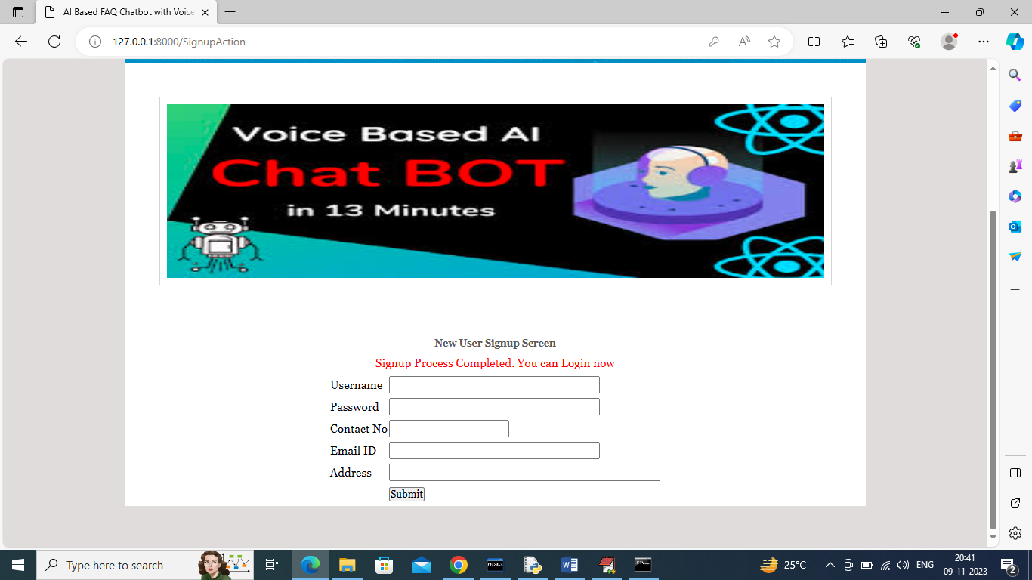

In above screen sign up process completed and now can login

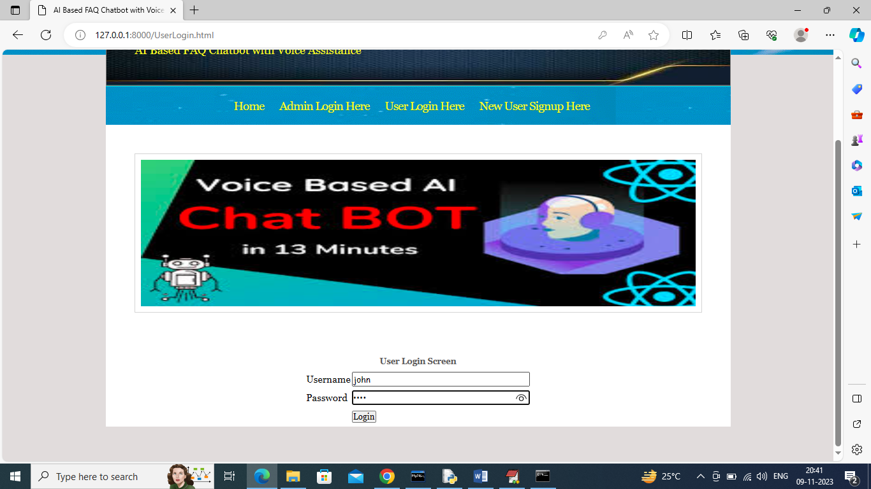

In above screen user is login and after login will get below page

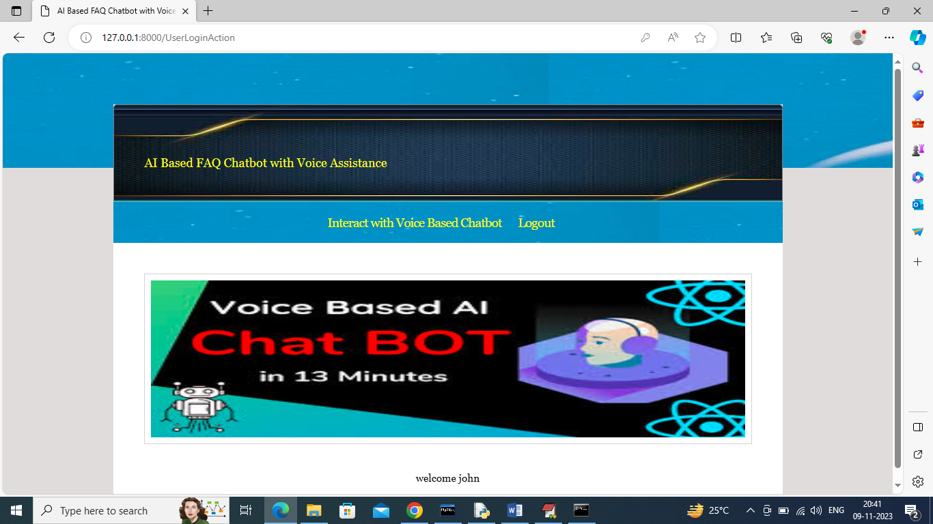

In above screen user can click on ‘Interact with Voice Based Chatbot’ link to get below page

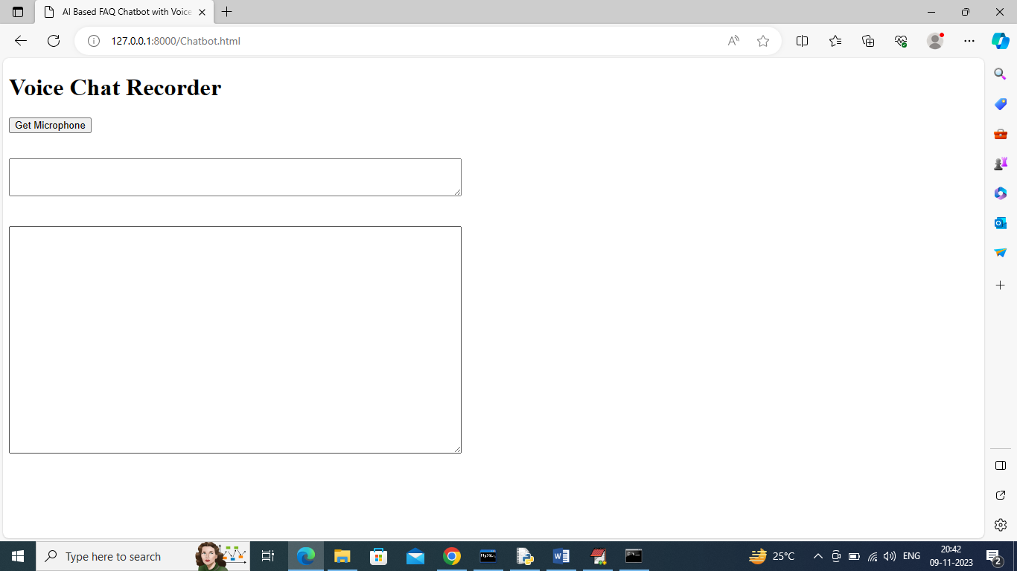

In above screen user can click on ‘Get Microphone’ link to connect to microphone and get below page

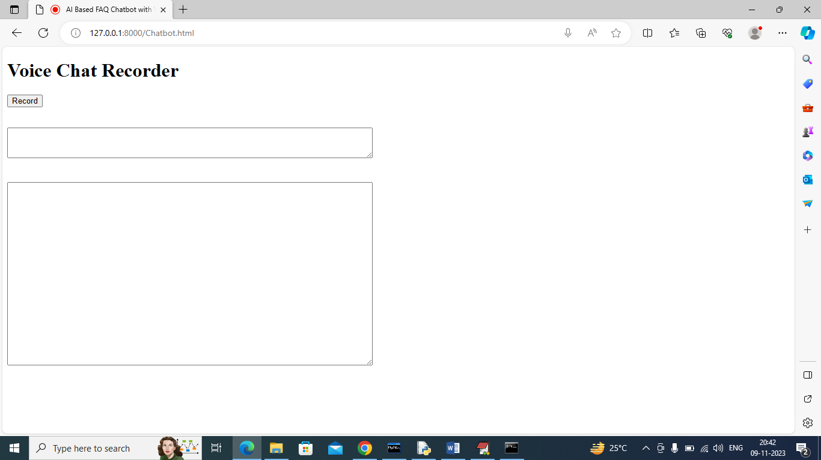

In above screen you can click on ‘Record’ button to record your voice and once done then click ‘Stop’ button to get response from Chatbot like below screen

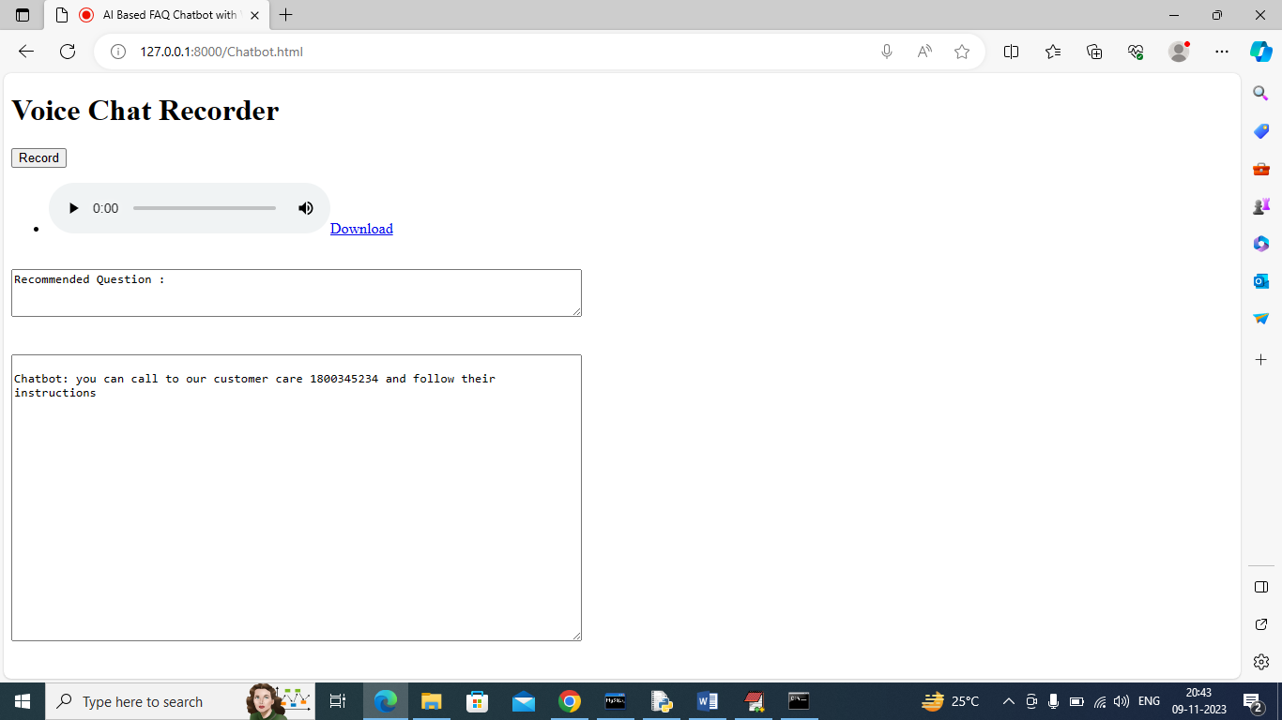

In above screen I speak some question about ‘return policy’ and then got above answer from Chatbot and whatever you record you can play and download any time. Below I am asking about working hours

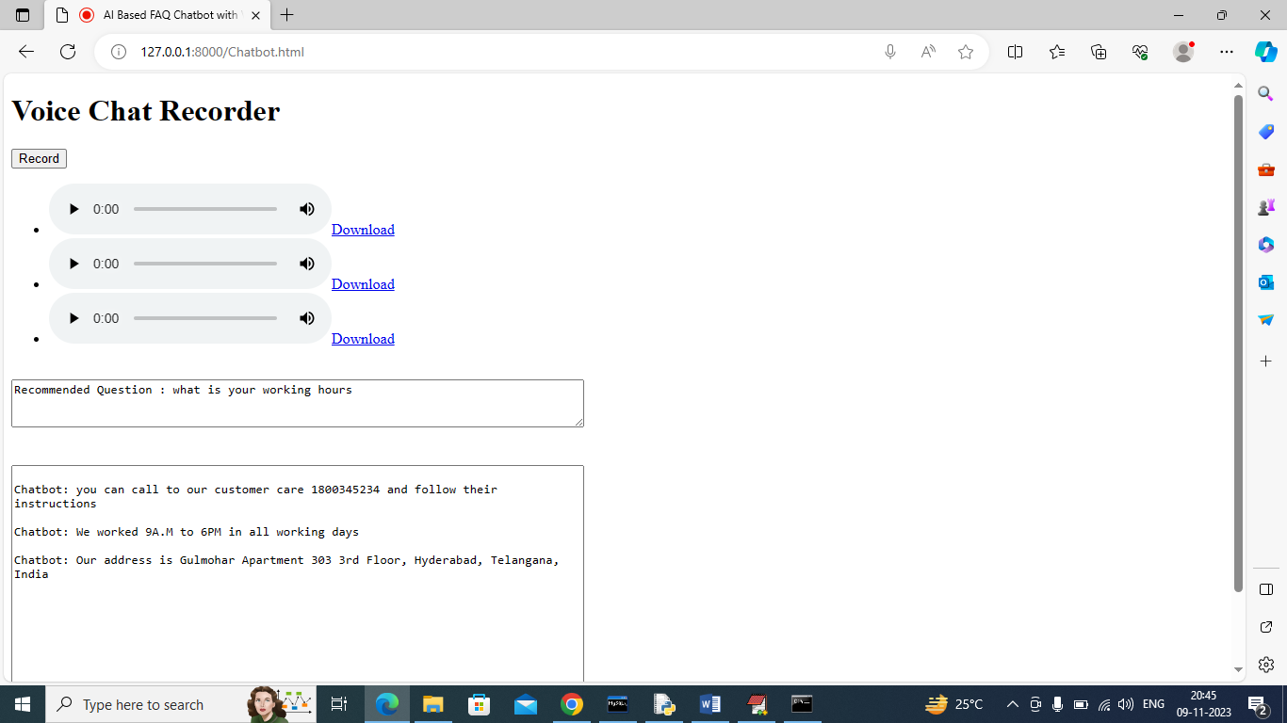

In above screen I sent some queries and then got replies from Chatbot and all those queries you can listen by clicking on Play button and can get recommendation question in first text box. In below screen I am asking unknown question

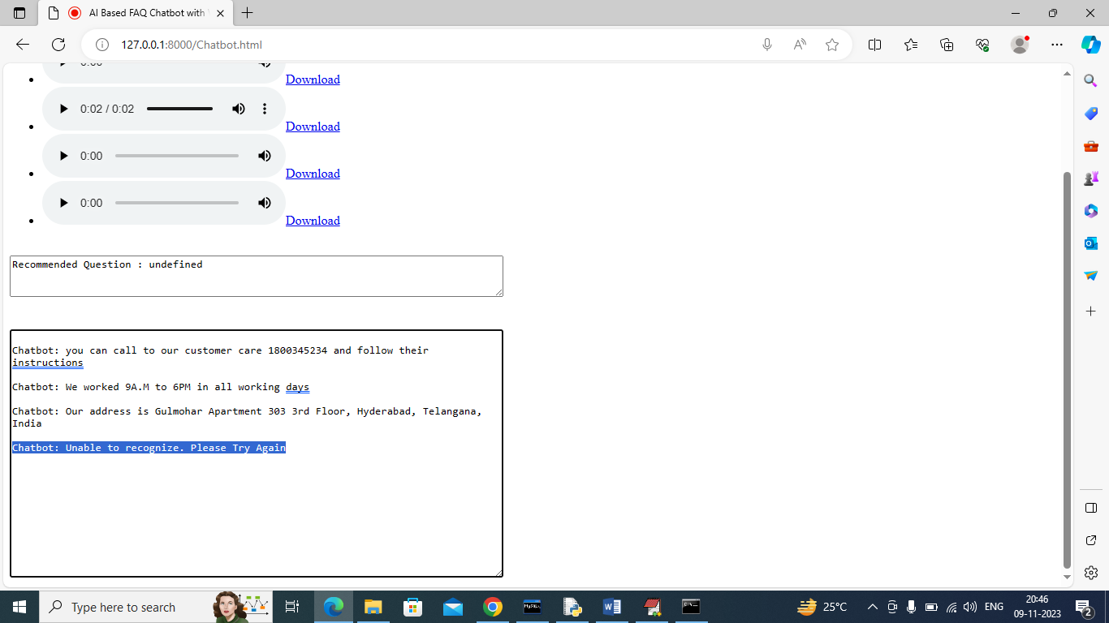

In above screen when I speak unknown question then Chatbot replied with ‘Unable to recognize and asked to try again’.

Similarly you can follow above screens to ask any FAQ question